Pollinators of Australian Acacias

Acacia is one of the most diverse of Australian genera, with 1075 currently accepted described species of Acacia in Australia. However, little is known about the actual pollinator species of acacias and this is outlined by Prendergast on this link: https://anpsa.org.au/wp-content/uploads/2025/05/Potential-pollinators-of-Acacia_v1.pdf. Given acacia flowers lack the typical floral rewards such as nectar that attract birds or other animals (e.g. bats, gliders), it has been widely accepted that Australian Acacias are insect pollinators. I found that Apis mellifera, Eristalis spp. (hoveryfly), beetles and a range of native flies were the pollinators of Acacia genistifolia for my Honours thesis in 1995 (click link to locate thesis, or find it in the menu item of “Pollination of Australian Acacia Research”). Many Acacia species do have an extrafloral gland positioned either on the upper margin of its phyllode or along the central vein of a bipinnate leafed wattle. An example of an extrafloral gland and inflorescence of Acacia pycnantha (Golden Wattle) is illustrated below.
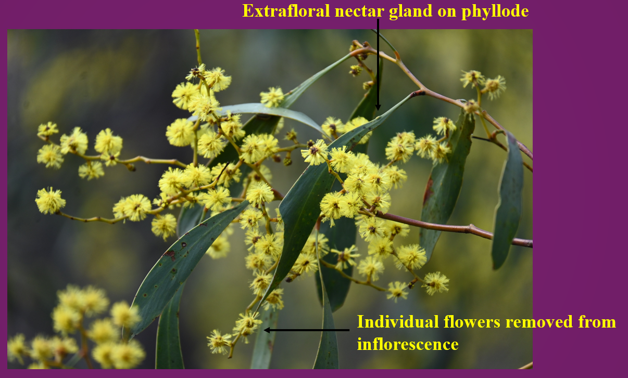
It has been widely accepted that extrafloral nectar glands produce a minute quantity of nectar that attracts ants, which in turn service the plant by protecting its foliage and reproductive tissues from phytophagous insects (known as the protectionists hypothesis). However, Vanstone and Paton (1988) found from exclusion experiments that birds pollinate Acacia pycnantha. They stated that the extrafloral nectar glands attracted the birds, which in turn caused pollination of the blossoms. Further they ascertained no protective function from the extrafloral nectar glands. In 1994 I performed research into the pollination of A. pycnantha as partial requirement for University qualifications, and witnessed quite often that birds probed inflorescences more regularly than the extrafloral nectar glands. Vanstone and Paton (1988) admitted they noticed this as well, thus, in 2023 I decided to take it upon myself to determine once and for all which is the predominant mode of bird pollination: extrafloral nectar glands attracting birds or birds probing the inflorescences for floral resources. I was astounded to find out that birds probing flowers either for arthropods and/or removing flowers and consuming them (eating flowers causing pollination!) was the predominant mode of pollination. Using an exclusion experiment I found that birds significantly caused removal of flowers from inflorescences (this patchy removal of flowers is pictured below the first paragraph in this text). Bird pollinators included honeyeaters (fuscous, white-naped, brown-headed, yellow-faced and Red Wattlebirds), silvereyes and thornbills. To examine more closely the evidence of this research click on “Pollination of Acacia pycnantha by birds feeding amongst flowers of inflorescences” for unpublished science journal or the laymen terms article “Pollination of Acacia pycnantha (Golden Wattle) by birds” or PowerPoint presentation. These resources are also in the menu item “Pollination of Australian Acacia Research”.
In 1994 I also noticed fuscous honeyeaters and white-naped honeyeaters probing the flowers of A. ausfeldii (a threatened species) and I followed this up in 2025. Again the aim was to determine how birds pollinate the flowers of this species, and the conclusion was the same as that for A. pycnantha. In this example, only fuscous honeyeaters were probing the inflorescences, and there was significant removal of flowers. To consult the evidence regarding this research please click the link “Pollination of Acacia ausfeldii by birds feeding amongst flowers of inflorescences”. Further, researchers have also found that Acacia terminalis was also being pollinated by birds.
Bird pollination could well be more widespread in Australian Acacia genera than originally thought. More recently birds were found to be proving flowers of A. dealbata inflorescences causing significant pollination. Future investigations would need to focus attention on other acacias that are winter-spring flowering (when insect activity is low), provide edible flowers, presence of potential bird pollinators and have inflorescences displaying ample flowers to determine if this type of bird-pollination is more widespread. Further, it is recommended that any future study into acacia bird pollination should address the relative roles that extrafloral nectar glands and floral probing has towards pod production.
Note: A full list of references can be located on the links provided in the unpublished science journal articles.
Below are pictures of birds probing inflorescences of Acacia pycnantha:
