Pollination of Acacia pycnantha (Golden Wattle) by birds
Acacia pycnantha is abundant within the box-ironbark bushland of the central goldfields region. Previous studies declared that the extrafloral nectar glands on the phyllodes of this species serve to attract birds to facilitate pollination. This is what was known from the previous studies:
- Exclusion experiments revealed birds to be significant pollinators (Vanstone & Paton, 1988; Nancarrow, 1994)
- Extrafloral nectar was secreted just prior to and during the flowering period only (1-4uL)
- Extrafloral nectar did not play a role in attracting ants for protection of the phyllodes from herbivorous arthropods
- Birds were observed to take the extrafloral nectar, and in the process, contact inflorescences and become brushed with pollen. However, silvereyes, thornbills and honeyeaters were also observed to peck other items amongst the inflorescences (Nancarrow, 1994)
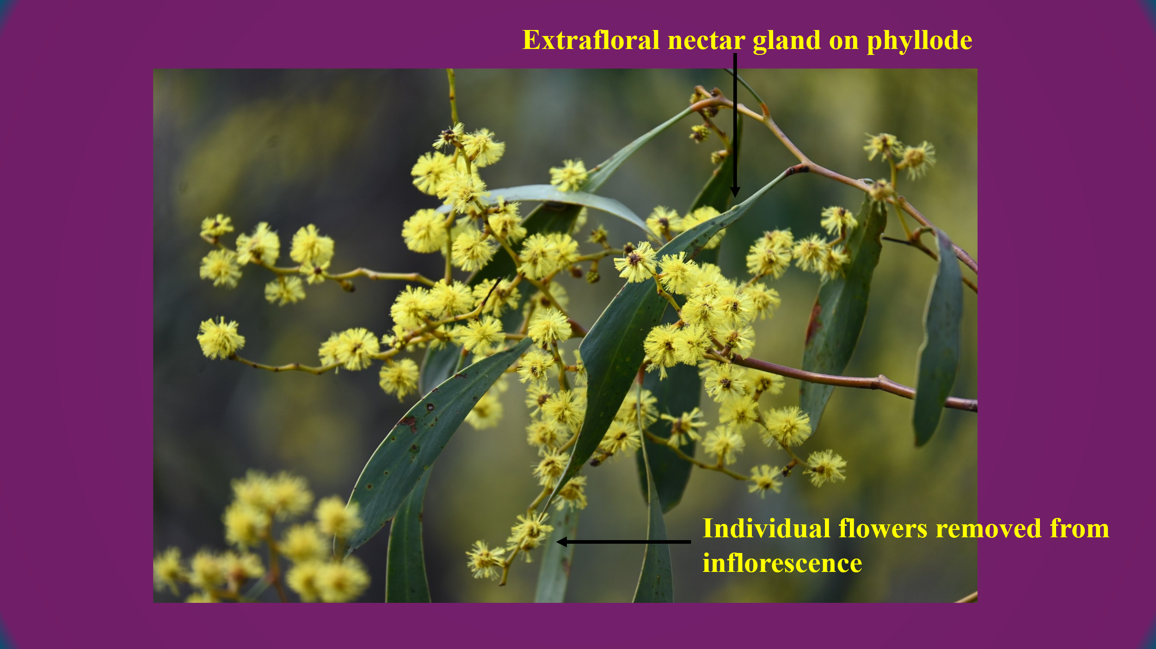
At this stage it was claimed extrafloral nectaries function to attract birds for pollination, but how effective is this pollination mode compared to that of birds feeding on items amongst the inflorescences? This is yet to be tested until now.
During the winter months of 2023 I aimed to resolve this problem and determine the relative role of the two pollination mechanisms: extrafloral nectar attracting birds or birds feeding amongst the blossom. The study site was adjacent to airport road halfway between Pekin Road and the Airport (Maryborough).
Three branches were randomly chosen on each of ten plants and the following treatments applied:
- Natural pollination (no applied treatment – both birds and insects able to visit inflorescences).
- Exclusion of birds from visiting flowers and/or extrafloral nectaries, but allow insect foragers to visit (see picture below).
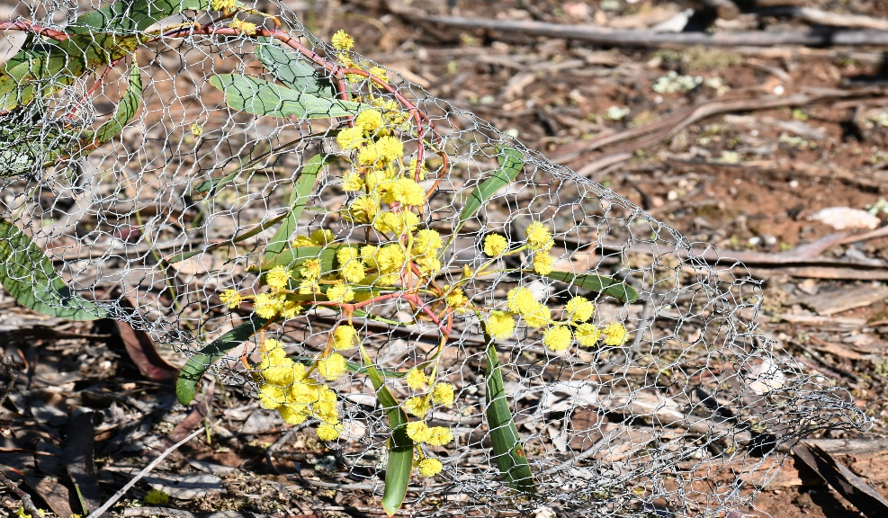
- Extrafloral nectaries (EFNs) removed from all phyllodes on the branch (birds and insects have access to inflorescences)
The results were as follows:
- Birds were significant pollinators of Golden Wattle.
- Extrafloral nectar glands did not significantly contribute to pollination of Golden Wattle
- Birds contribute significantly to removal of flowers from inflorescences
The flowering period occurred from late June through to the first week in September, which meant the temperatures were low and not conducive to insect activity. In fact observations revealed a very low frequency of Apis mellifera (Introduced honeybee) and Eristalis spp. (hoverfly). However, a number of bird species were frequently observed to peck at inflorescences and even remove flowers from the inflorescences, but rarely probed at extrafloral nectar glands. There were significantly more flowers removed from the bird inclusive treatment (natural pollination) than the bird exclusion treatment. The chief bird species were Fuscous honeyeater, White-naped honeyeater, Yellow-faced honeyeater, Red Wattlebird and Silvereyes. Buff-rumped thornbill and Yellow-tufted honeyeaters were occasionally observed to forage in this manner. One would immediately think that removal of flowers would not be a service at all for the plant’s success at pollination, however, the reverse situation prevailed. In fact birds contributed to double the number of inflorescences setting pods, and double the number of pods setting per inflorescence compared to insects. Golden wattle has on average 46 flowers per inflorescence (36-56) but only a fraction of these were removed by birds (generally five to ten flowers). The maximum number of pods that set on an inflorescence was 8 pods with an average of 2.2 (natural pollination treatment). Further, extrafloral nectar glands did not enhance pollination success as there was no difference in the number of inflorescences setting pods between the EFN exclusion versus EFN inclusion treatment. In conclusion the dominant pollination mechanism was birds foraging amongst the blossoms, particularly the removal of flowers which is so atypical of bird-pollinated plants. In fact I have found no records of this pollination mechanism from other plant species.
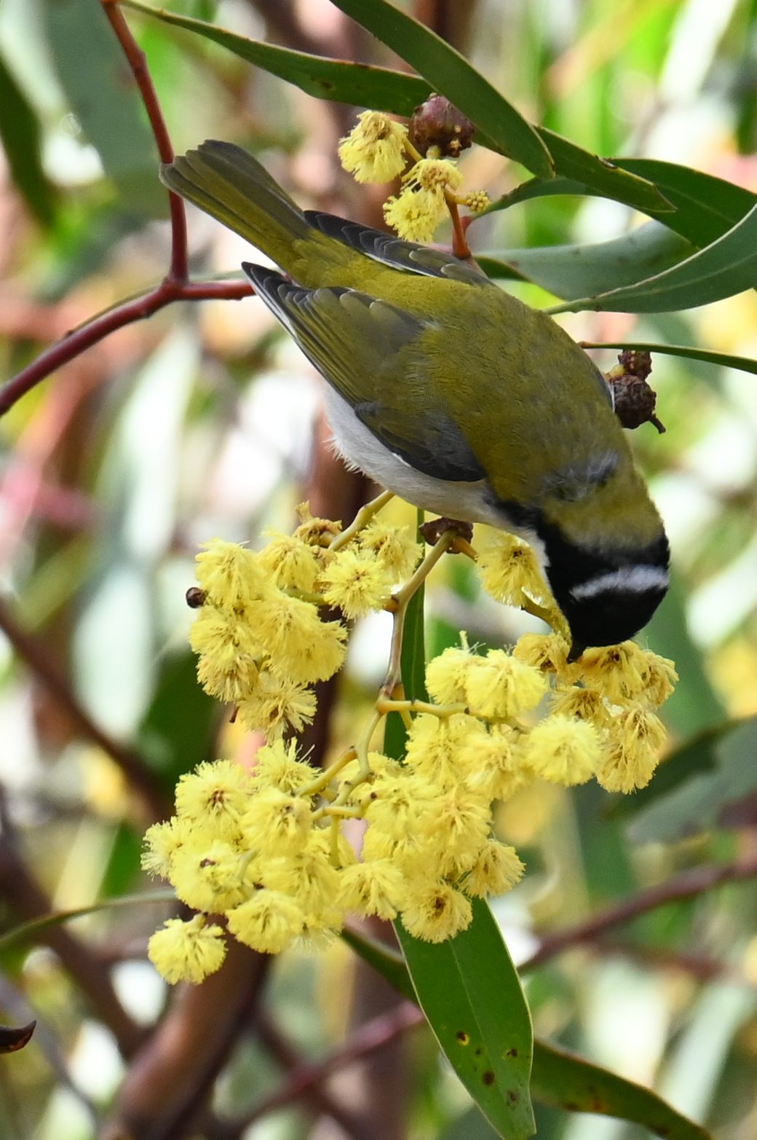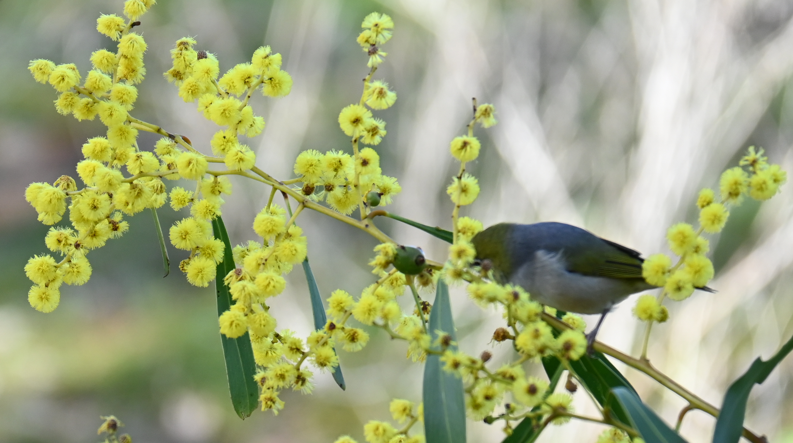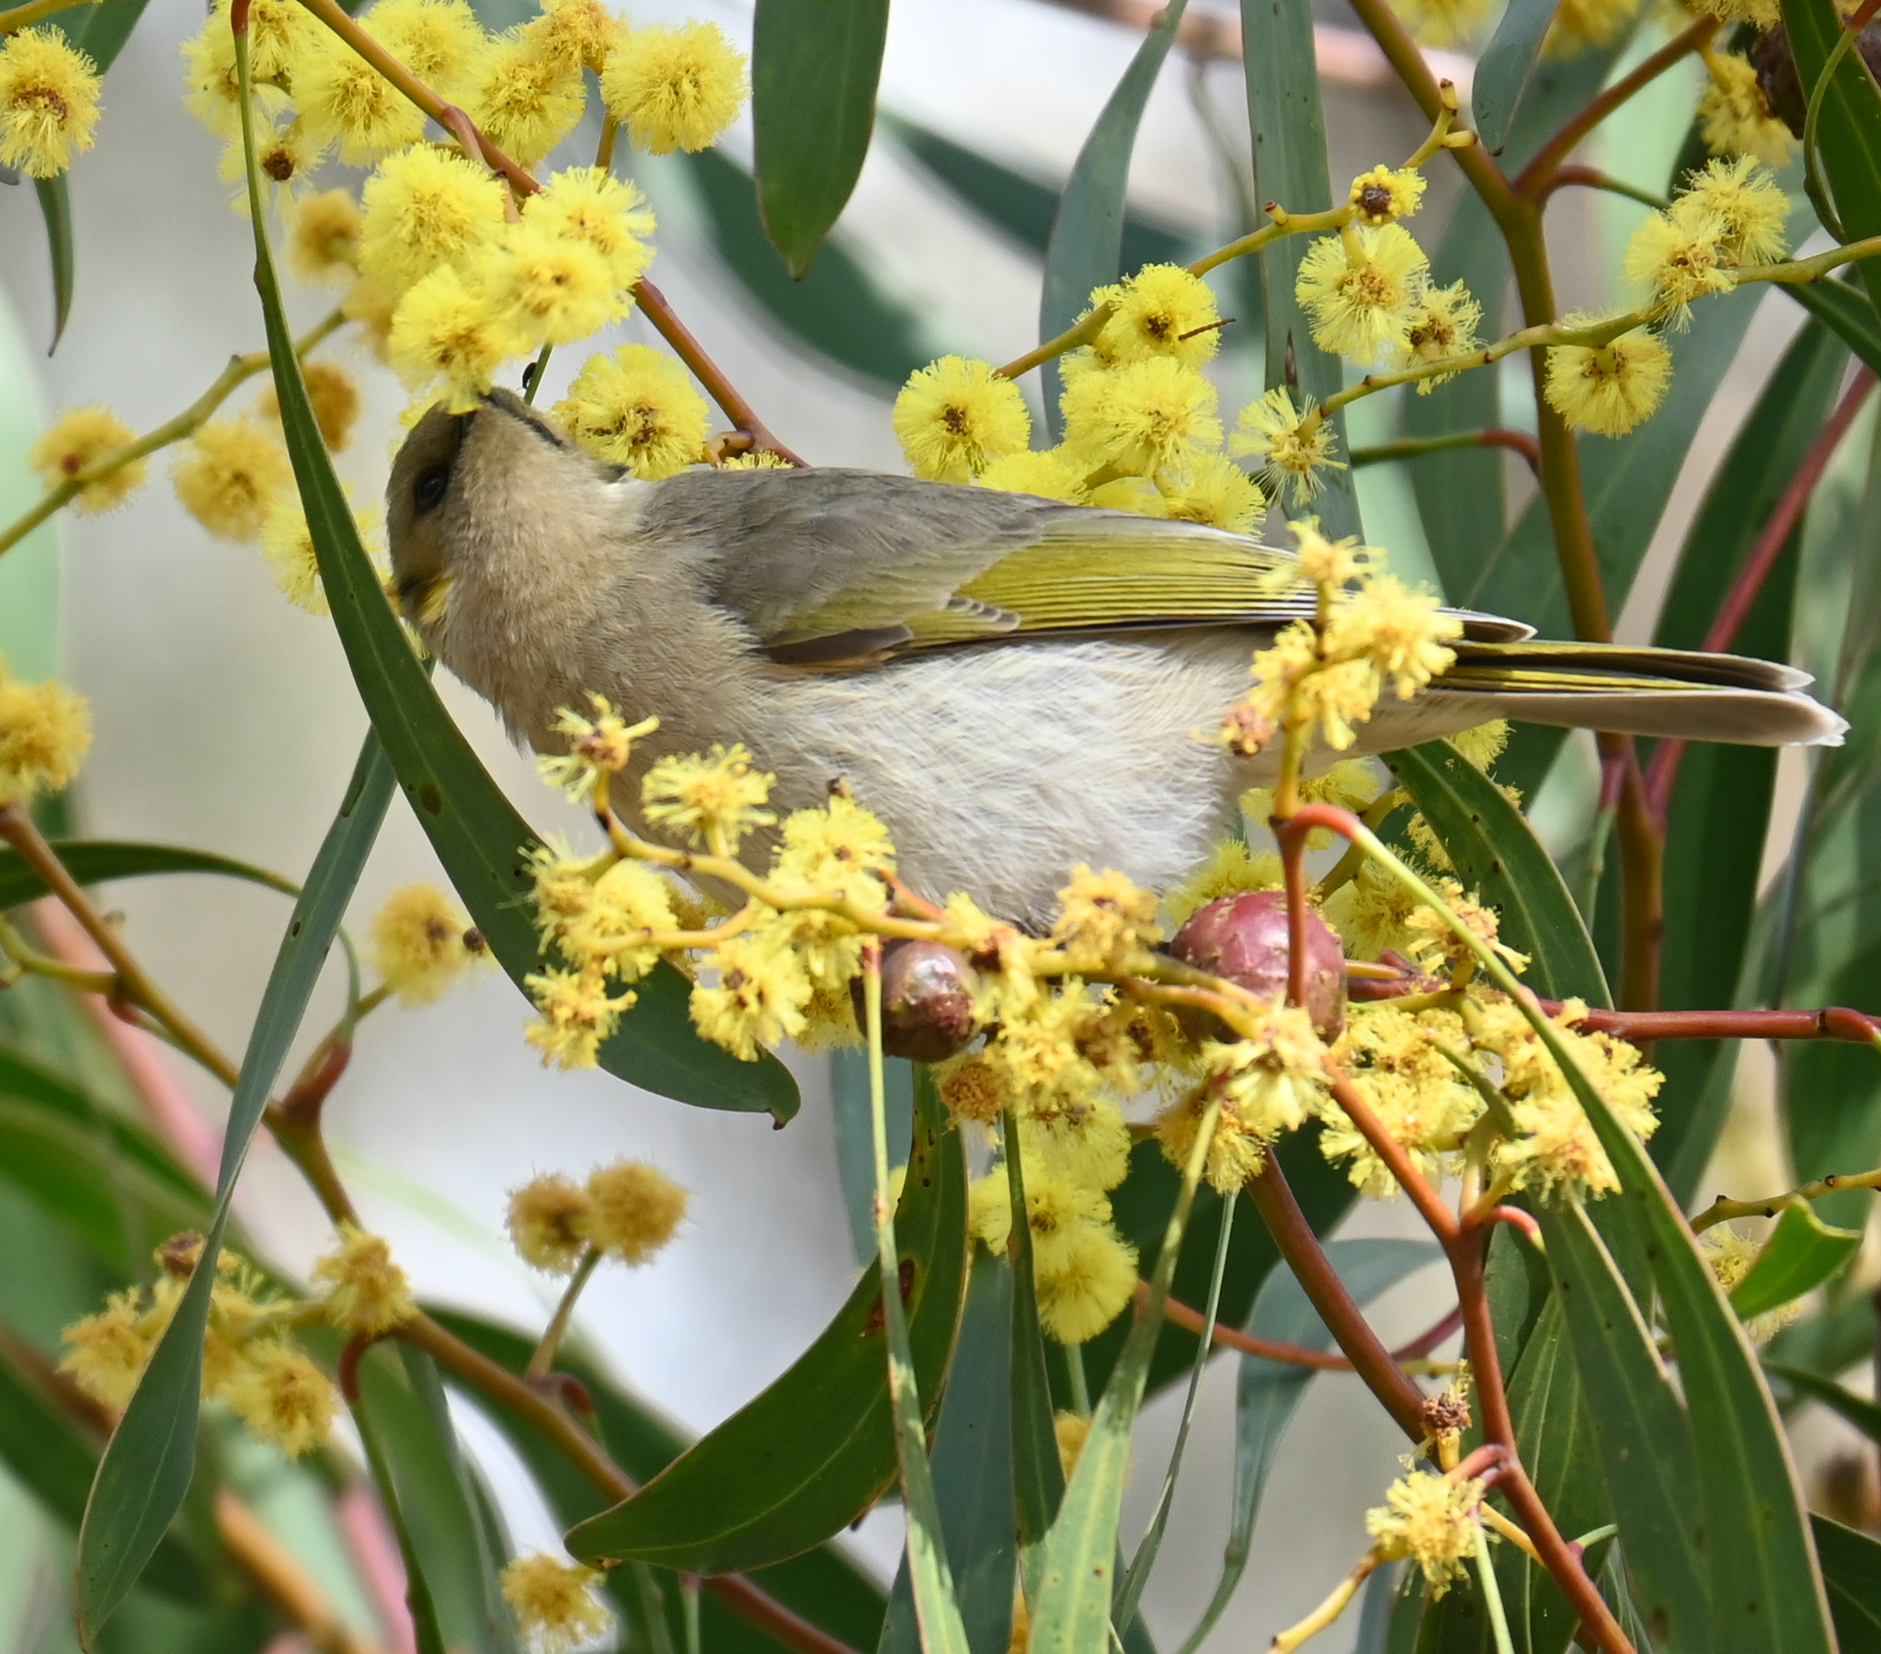
Future investigations would need to focus attention on other acacias that are winter flowering, provide edible flowers plus display a sufficient number of flowers per inflorescence to determine if this type of bird-pollination is more widespread within the Acacia genera. If any members have ideas on acacia species that may fit this role please let me know as I would be keen to pursue more research into this area.
Further, it is recommended that any future study into acacia bird pollination should address the relative roles that extrafloral nectar glands and floral pecking has towards pod production.
References
1. Nancarrow, C.D. (1994). Pollination Ecology of Acacia pycnantha Benth. and A. ausfeldii Regel. (Research project submitted as partial requirement for Bachelor of Applied Science LaTrobe University, Bendigo).
2. Vanstone, V.A., and Paton, D.C. (1988). Extrafloral nectaries and pollination of Acacia pycnantha Benth. by birds. Australian Journal of Botany 36, pp519-31.

